SENTINEL: AN INTEGRATED SECURITY OPERATIONS MANAGEMENT SYSTEM FOR DAVAO SECURITY & INVESTIGATION AGENCY, INC.

A Capstone Project
Proposal Presented to the Faculty of the
Information and Communications Technology Program STI College Tagum

In Partial Fulfillment
of the Requirements for the Degree Bachelor of Science in Information Systems

HANZ LOURENZ FRANK J. RIBU
HECTOR PHILLIP P. LACIERDA
APPLE JOHN D. LUMINGKIT
DWIGHT KARL B. GAGA-A
GAD ABRAHAM M. JOSE

May 2026

ENDORSEMENT FORM FOR PROPOSAL DEFENSE

TITLE OF RESEARCH: SENTINEL: An Integrated Security Operations Management System for Davao Security & Investigation Agency, INC.

NAME OF PROPONENTS: Hanz Lourenz Frank J. Ribu
Hector Phillip P. Lacierda
Apple John D. Lumingkit
Dwight Karl B. Gaga-a
Gad Abraham M. Jose

In Partial Fulfilment of the Requirements
for the degree Bachelor of Science in Information Systems
has been examined and is recommended for Proposal Defense.

ENDORSED BY:

Mr. Eldito C. Loquinio, MIT
Capstone Project Adviser

APPROVED FOR PROPOSAL DEFENSE:

Mr. Allimar M. Nuevo, MM, CGSP, CHIA
Capstone Project Coordinator

NOTED BY:

Mr. Eldito C. Loquinio, MIT
Program Head

May 12, 2026

APPROVAL SHEET

This capstone project proposal titled: SENTINEL: An Integrated Security Operations Management System for Davao Security & Investigation Agency, INC. prepared and submitted by Hanz Lourenz Frank J. Ribu, Hector Phillip P. Lacierda, Apple John D. Lumingkit, Dwight Karl B. Gaga-a and Gad Abraham M. Jose, in partial fulfillment of the requirements for the degree of Bachelor of Science in Information Systems, has been examined and is recommended for acceptance and approval.
Mr. Eldito C. Loquinio, MIT
Capstone Project Adviser

Accepted and approved by the Capstone Project Review Panel in partial fulfillment of the requirements for the degree of Bachelor of Science in Information Systems

Ms. Iris Mae Mendoza, MIT | Mr. Allimar M. Nuevo, MM, CGSP, CHIA
Panel Member | Panel Member

Mr. Benjamin M. Mahinay, MIT
Lead Panelist

Noted:

Mr. Allimar M. Nuevo, MM, CGSP, CHIA | Mr. Eldito C. Loquinio, MIT
Capstone Project Coordinator | Program Head

May 12, 2026

TABLE OF CONTENTS

TITLE PAGE i
ENDORSEMENT FORM FOR PROPOSAL DEFENSE ii
APPROVAL SHEET iii
TABLE OF CONTENTS iv
INTRODUCTION 1
Project Context 1
Purpose and Description 3
Objectives 4
Scope and Limitations 9
Review of Related Literature/Studies/Systems 13
METHODOLOGY 22
Requirements Analysis 28
Design of Software, System, Product, and/or Processes 34
REFERENCES 55

INTRODUCTION

Project Context
The private security global industry is transitioning toward automated, high-integrity digital ecosystems to address the discovery lag inherent in human-led monitoring. Global research in workforce capacity indicates that manual, reactive responses to personnel gaps significantly increase vacancy time, which remains a primary driver of security breaches in critical infrastructure (Shiyanbola et al., 2023). This movement is supported by modern performance management theories which emphasize that transparent, data-driven tracking is essential to maintaining accountability and preventing social loafing, a phenomenon where individual reliability decreases in the absence of structured, real-time monitoring (Aguinis, 2022).
The necessity for these technological advancements is echoed in recent Philippine legislation through the Private Security Services Industry Act, also known as Republic Act No. 11917 (2022). This law introduced a regime of professionalized accountability where agencies face strict liability for administrative negligence. Under the law’s Implementing Rules and Regulations, agencies can be fined up to P5,000,000 or face license revocation for deploying personnel with expired licenses or unauthorized firearms (Jur.ph, 2025). Furthermore, national studies on the effectiveness of Philippine security guards identify that absenteeism and the abandonment of posts are most prevalent in agencies that lack advanced patrol monitoring and digital reporting systems (Abad, 2025).
In the specific context of the Davao Region, the Davao Security and Investigation Agency, Inc. operates in a landscape that has prioritized a culture of security to sustain its position as a leading safe haven in Southeast Asia (PIA, 2025). According to the Davao Regional Development Plan 2023 to 2028, the region's rapid economic growth has increased the demand for advanced technology and innovation to ensure peace and security in high-traffic logistics and commercial hubs like Tagum City (NEDA XI, 2024). Recent local research conducted in the Davao Region specifically highlights that compensation, punctuality, and alertness are the primary determinants of guard performance, yet many regional agencies still struggle with inattentiveness and abandonment of posts due to inconsistent manual oversight (Ondos and Origines, 2025). For DASIA Tagum, this represents a critical vulnerability where site vacancies may go undetected for hours, directly compromising the safety of local clients.
SENTINEL is an integrated security operations platform designed to address these vulnerabilities by centralizing personnel profiles, firearm inventory and custody records, and shift logs into a unified source of operational data. The scheduling workflow validates that guards are approved and checks for conflicting assignments before a schedule is created. Firearm allocation separately validates firearm availability, permit status, and applicable firearms-handling training before normal issuance. When a no-show condition is detected, SENTINEL can notify eligible guards and provide ranked replacement recommendations based on operational factors such as reliability, availability, permit status, and last-known distance. Authorized personnel or an eligible guard then confirm the reassignment. To manage high-concurrency requests from hundreds of guards, SENTINEL utilizes the Rust programming language and the Axum framework, providing native memory safety and asynchronous performance that prevents the data races typical of legacy systems (Scofield, 2025).

Purpose and Description
The primary purpose of this capstone project is to design, implement, and deliver SENTINEL as an integrated security operations and management platform for Davao Security and Investigation Agency, Inc. The study addresses fragmented manual oversight by consolidating core operational processes into a role-governed environment that supports timely command decisions, field coordination, and institutional accountability.
SENTINEL provides unified support for identity and access governance, workforce administration, asset and permit compliance, incident coordination, support and notification workflows, and real-time situational awareness. Role-based and policy-based controls restrict sensitive functions to authorized users and preserve traceable records for institutional review. In the current user-facing product, protected access is administrator-mediated, approval-governed, and policy-gated rather than exposed as open public self-registration through the login experience.
Operationally, the system supports scheduling, attendance, no-show detection, replacement handling, and role-specific dashboard workflows to sustain deployment continuity. For field use, the implemented guard experience includes check-in and check-out actions, emergency contact access, panic escalation, and selected offline continuity for high-priority actions. SENTINEL also manages firearm and vehicle lifecycles, including issuance, return, maintenance, trip visibility, and permit-sensitive checks, to strengthen asset accountability and reduce service disruption.
At the command level, the platform integrates live tracking signals with structured operational records to provide timely visibility of personnel movement, incident status, deployment conditions, and site-aware activity. Geofence monitoring, notifications, quick Inbox timelines, and incident workflows support faster coordination across command and field roles.
Security and governance controls are embedded as core functions, including secure session management, legal-policy acceptance gating, audit and forensic logging, rate limiting, and service-health monitoring. The Web application serves as the currently implemented primary runtime. Windows desktop packaging through Tauri and Android packaging through Capacitor are configured as additional deployment targets. Packaged installer and signed-device validation remain necessary before full cross-platform parity can be established.

Objectives
General Objective
The main objective of this study is to develop SENTINEL, an integrated, role-governed security operations management system for the stakeholders of Davao Security & Investigation Agency, Inc. The system supports workforce continuity, asset accountability, incident coordination, operational monitoring, and governance visibility through an implemented Web application with configured Windows desktop and Android deployment targets.
Specific Objectives
- Provide secure, approval-governed user access with identity verification, session management, account recovery, and legal-policy compliance.
- Automate personnel operations, including scheduling, attendance, DTR generation, check-in/check-out, and replacement coordination.
- Strengthen firearm, permit, vehicle, and asset accountability through reports, expiration alerts, issuance tracking, and maintenance monitoring.
- Support field operations through incident reporting, emergency escalation, service requests, notifications, and live monitoring.
- Provide performance evaluation and analytics through graphical reports on attendance, punctuality, incidents, assignments, and guard performance.
- Deliver a traceable security operations system with an implemented Web application and configured Windows desktop and Android deployment targets, supported by audit logs, approval workflows, and operational reports.

Scope and Limitations
Scope
The SENTINEL system covers the implemented operational, compliance, and governance requirements of a private security agency within the regulatory context of Republic Act No. 11917 (2022). The scope includes role-governed command and field workflows, centralized operational records, quick-action coordination surfaces, near-real-time situational monitoring, decision-support outputs, and forensic audit visibility. The Web application is the implemented primary runtime. Windows desktop packaging through Tauri and Android packaging through Capacitor are configured deployment targets; packaged and signed runtime validation remains required before full platform parity can be established.
Data
- Personnel profiles, human-readable Guard IDs, role and approval data, licensing and permit records, schedules, attendance logs, availability status, merit indicators, and legal-consent records.
- Firearm inventory records, allocations, maintenance history, and permit-compliance data.
- Armored vehicle assets, allocations, driver assignments, trip records, and maintenance history.
- Missions, incidents, support tickets, notifications, operational alerts, emergency alerts, location records, inbox summaries, workflow history, and audit logs.
- Geofence events, site geofence definitions, movement-history records, forensic activity traces, and anomaly evidence for post-incident review.
- Authentication lockout records, session lifecycle records, and audit source-IP traces for security accountability.
- Release and service-health records required for runtime governance and operational monitoring.
Process
- Account lifecycle workflows, including controlled onboarding, verification, authentication, recovery, and profile maintenance.
- Approval workflows for newly onboarded guard accounts before operational access is granted.
- Role-based dashboards for command monitoring, approvals, analytics, scheduling, audit review, and profile management.
- Desktop command dashboards support adjustable navigation density while preserving usable shell behavior across desktop and mobile form factors.
- Role-based inbox and quick-action workflows for prioritized tasks, approvals, incidents, notifications, asset-related actions, shift issues, and workflow history.
- Mission-first guard workflows for field reporting, attendance actions, instructions review, emergency-contact access, panic escalation, selected offline continuity, and map-supported navigation.
- Shift scheduling, attendance validation, no-show detection, replacement coordination, and supervisor oversight.
- Firearm issuance and return workflows with permit validation, maintenance scheduling, and custody traceability.
- Vehicle allocation, driver assignment, trip lifecycle management, and preventive and corrective maintenance tracking.
- Incident reporting, emergency escalation, support ticket handling, notification delivery, and live operational monitoring.
- Guard movement reconstruction, including active roster monitoring, historical trail replay, patrol reconstruction, and geofence escalation.
- Audit forensics workflows, including timeline filtering, actor-specific activity reconstruction, anomaly review, and case sequencing.
- Session security workflows, including renewal control, sign-out revocation, and lockout persistence.
- Legal confirmation workflows, including policy review, mandatory acceptance capture, and access gating until accepted.
People
- Superadmin, Administrator, Supervisor, and Guard roles with distinct permissions and dashboard views.
Technology
- Web-based application accessible on desktop and mobile browsers.
- Configured Windows desktop packaging through Tauri and Android packaging through Capacitor as additional deployment targets, subject to packaged-release validation.
- React + TypeScript frontend and Rust + Axum backend services.
- Centralized PostgreSQL database with relational integrity, auditability, and role-based data control.
- Dockerized deployment and service-based architecture with live tracking synchronization, audit telemetry, and governed release packaging.

Limitation of the Study
The limitations of this study refer to the exclusions and constraints that were beyond the intended scope and implementation coverage of the developed system. These include, but are not limited to: (1) the exclusion of direct integration with external payroll systems, human resource platforms, government licensing databases, and third-party security hardware ecosystems such as CCTV, IoT sensors, and access-control devices; (2) technological constraints related to the system’s dependence on application-generated location updates, device GPS accuracy, network stability, and the provision of only partial offline support for selected high-priority guard actions. While GPS-based tracking provides more accurate and reliable location data for operational monitoring, IP-based location tracking remains less precise and may not consistently reflect the exact real-time position of field personnel; and (3) implementation constraints, wherein certain backend-supported capabilities, such as direct training-record administration and full geofence-zone administration, are not yet fully exposed through complete end-user command surfaces, while some workflows remain consolidated within shared dashboard panels, tabs, and shell overlays rather than being deployed as fully independent standalone modules.

Review of Related Literature/Studies/Systems
Related Literature
The Philippine private security sector is currently navigating its most significant legal transition in over fifty years. The enactment of the Private Security Services Industry Act (Republic Act No. 11917, 2022) effectively repealed the outdated RA 5487, shifting the industry toward a regime of "Professionalized Accountability." According to Jur.ph (2025), the law’s Implementing Rules and Regulations (IRR) mandate that Private Security Agencies (PSAs) maintain highly accurate, digitized records of License to Exercise Security Profession (LESP) and firearm permits. The act introduces a "strict liability" framework where administrative negligence, such as deploying an unlicensed guard, can result in fines ranging from ₱50,000 to ₱100,000 per violation, or up to ₱5,000,000 for agency-wide license failures.
This regulatory pressure has necessitated a move toward Automated Regulatory Compliance Tracking (ARCT). Research by Khinvasara, T., Shankar, A., & Wong, C. (2024) suggests that for organizations managing complex, shifting rules, the use of automated monitoring is a "significant advancement" that eliminates the "discovery lag" inherent in manual audits. By leveraging system-driven triggers for license expirations, PSAs can transition from reactive compliance to a proactive stance, ensuring that no personnel or asset is deployed without valid legal authorization.
Operational continuity in the private security sector is heavily dependent on reliable guard presence. As identified in the operational risks of DASIA Tagum, "No-Show" incidents represent a critical vulnerability where manual processes relying on phone calls and delayed human intervention fail to address "discovery lag." Research in workforce capacity optimization emphasizes that manual, reactive responses to workforce gaps significantly increase "vacancy time," directly correlating with higher security breach probabilities (Shiyanbola et al., 2023).
Modern systems mitigate this by automating the identification and deployment of replacements based on real-time availability, shifting the organizational stance from reactive crisis management to proactive risk mitigation (Al-Khafajiy et al., 2022). Furthermore, automated scheduling alerts now enable "rule-based no-show monitoring", which analyzes historical No-Show data to alert administrators of potential gaps before they occur, drastically reducing the operational vacancy time (TrackTik, 2025).
The transition from inconsistent, manual tracking to a structured, data-driven framework is essential for maintaining Distributive Justice, the perceived fairness of how shifts, rewards, and responsibilities are allocated within an organization. Aguinis (2022) posits that the absence of a structured performance management framework leads to "Social Loafing," a psychological phenomenon where employees decrease effort due to a perceived lack of individual accountability.
For security agencies like DASIA Tagum, implementing centralized performance metrics such as punctuality and client feedback logs ensures that shift allocation is based on objective data rather than subjective selection. This transparency not only increases overall guard reliability but also fosters a culture of accountability, as guards understand that their performance is directly linked to future opportunities (Tan et al., 2024).
The systematic allocation of firearms is a matter of both Chain of Custody (CoC) and legal necessity under the Private Security Services Industry Act (Republic Act No. 11917, 2022). The law mandates strict accountability for firearms, requiring that only authorized, trained, and compliant guards carry weapons. Manual processes often suffer from "data drift," where the status of a weapon and the permit validity of the assigned guard are not reconciled in real-time, leading to potential administrative negligence. Centralized digital tracking is identified as the primary defense against the misallocation of high-risk equipment and is a prerequisite for generating the legally defensible audit logs required by the National Cybersecurity Plan 2022-2028 (DICT, 2024; PNP-SOSIA, 2022).
The selection of the backend technical stack is a core security decision for mission-critical systems. Scofield, M. B. (2025) argues that Rust’s "ownership and borrowing" model provides a fundamental architectural advantage: Memory Safety without a Garbage Collector. This ensures that SENTINEL is natively resistant to buffer overflows and data races, vulnerabilities that often plague systems handling high-concurrency data like real-time firearm tracking.
Complementing the language is the Axum framework, which is built on the Tokio asynchronous runtime. As highlighted by NashTech (2025), Axum is designed for high-performance web services where scalability and raw speed are non-negotiable. For SENTINEL, this means the Attendance Tracking and No-Show Detection modules can handle hundreds of simultaneous "check-in" requests during shift rotations without performance degradation. This "asynchronous-first" design allows the system to remain responsive even when processing complex relational logic across personnel, vehicle, and firearm databases.
In an Integrated Operations Platform, the database must serve as the immutable "Single Source of Truth." PostgreSQL (2025) is recognized as the premier open-source RDBMS for enterprise planning due to its strict adherence to ACID (Atomicity, Consistency, Isolation, Durability) properties. Nguyen, R. (2025) emphasizes that PostgreSQL’s implementation of Foreign Key Constraints and Unique Exclusion Constraints is the primary defense against "data drift."
In the SENTINEL ecosystem, these constraints ensure that a firearm or armored vehicle cannot be logically "double-booked" or assigned to a guard who does not exist in the personnel table. This high level of relational integrity is a prerequisite for generating the legally defensible Audit Logs required by the National Cybersecurity Plan 2023-2028 (DICT, 2024), ensuring that every asset movement is tied to a verifiable digital identity.
Empirical research confirms that automated oversight is a primary driver of operational integrity. A study by Atlam, H. F., & Yang, Y. (2025) found that organizations utilizing unified Access Control and Resource Planning (ERP) systems saw a 27% drop in unauthorized access violations and reclaimed 36% of staff time previously lost to manual verification. These findings suggest that hardwiring compliance into the system architecture, rather than treating it as an afterthought, tightens process integrity and reduces the risk of internal data tampering.
Furthermore, research by Shiyanbola, J. O., et al. (2023) on "Workforce Capacity Optimization" highlights a flaw in traditional security: "discovery lag." This occurs when supervisors only identify a personnel gap after a shift has failed. Their study demonstrates that real-time, asynchronous detection models allow for a proactive 11.8% improvement in site coverage reliability. Locally, ResearchGate (2025) cites a study by Respicio (2023) which found that Philippine security guards operating under digital monitoring exhibited significantly higher levels of alertness and punctuality because the system provided a transparent, inescapable layer of accountability that manual logs could not match. The functional blueprint of SENTINEL is informed by the performance of several industry-leading platforms such as TrackTik and Guardhouse.
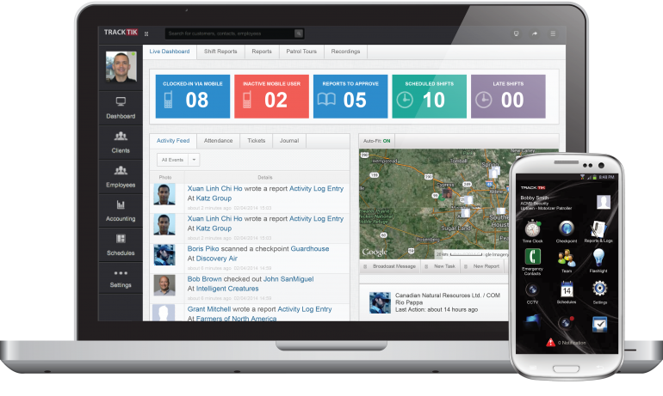
Figure 1. TrackTik
TrackTik (2025) has redefined security workforce management by moving beyond static scheduling toward an integrated, AI-driven operational model. According to the Trackforce 2025 Physical Security Operations Benchmark Report, the industry is currently facing an "AI adoption paradox" where the value of predictive scheduling is recognized, but cost remains a barrier for mid-sized firms. TrackTik’s success is anchored in its ability to consolidate alarm monitoring, guard dispatch, and business administration into a single 24/7 resilient architecture, which users report has increased operational efficiency by approximately 20%. This efficiency is primarily attributed to the reduction of manual administrative burdens through automated compliance tracking and real-time intelligence feeds (TrackTik, 2025).
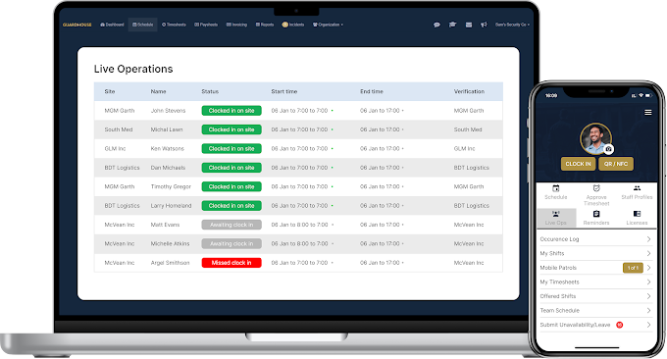

Figure 2. Guardhouse
Guardhouse (2026) addresses the specific administrative "overload" that has become a measurable barrier to performance in the mid-2020s. Research from NODE Magazine (2026) indicates that security employees often lose an average of 15 hours per week to routine administrative tasks, such as re-entering data across fragmented systems. Guardhouse mitigates this by unifying scheduling, GPS tracking, and invoicing into a streamlined workflow, reportedly reducing office-based administrative time by 40–60%. Its "Confidence in Compliance" module provides a specialized framework for daily license verification, a logic that SENTINEL adapts to specifically meet the stringent requirements of RA 11917 (GetApp, 2026).

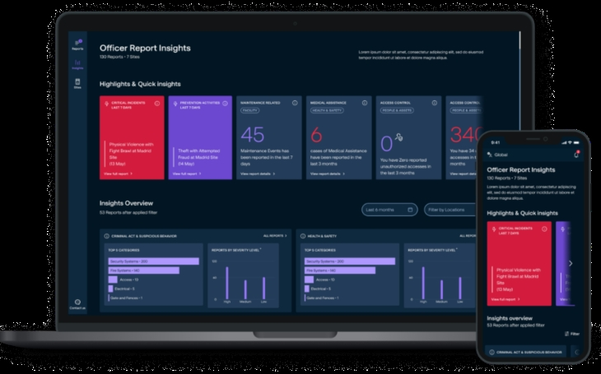
Figure 3. MySecuritas
Securitas "MySecuritas" (2026) represents the industry’s shift toward "Situational Understanding" and proactive risk management. The Securitas 2026 Global Technology Outlook Report identifies that the rapid advancement of generative AI for contextual understanding is now a top priority for 30% of security decision-makers (Securitas Technology, 2025). MySecuritas operationalizes this by providing a unified dashboard that transforms disparate incident reports into actionable statistics and trend highlights. This allows supervisors to identify risk patterns before they escalate, a core design principle mirrored in SENTINEL’s Performance Analytics Dashboard (Securitas, 2026).

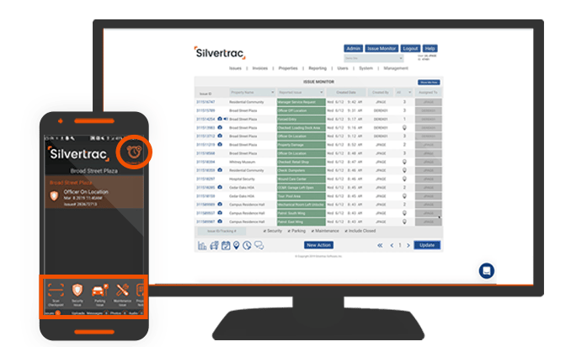

Figure 4. Silvertrac Software
Silvertrac Software (2026) is widely utilized for "Proof of Performance" and on-site accountability, particularly in parking and property management environments. While it excels in field reporting and checkpoint verification via mobile applications, its architectural focus remains on incident management and officer accountability (Silvertrac Software, 2026). Technical evaluations of generic guard management systems suggest a persistent "visibility gap" in specialized asset tracking; most platforms lack the deep relational logic required for a Digital Chain of Custody for high-risk assets like firearms and armored car fleets (Hardcat, 2025). SENTINEL fills this niche by integrating these high-stakes logistics, traditionally managed in siloed armory or fleet software, into the primary workforce management ecosystem.
Across the reviewed literature, several consistent themes emerge. Researchers emphasize the importance of integrating operational data to improve organizational visibility and decision-making. Studies from both Philippine and international contexts highlight the limitations of fragmented monitoring tools and manual processes.
Technological trends such as automated scheduling algorithms, attendance tracking, and operational dashboards are increasingly adopted across industries. However, existing systems often address only a single domain of operations, such as workforce scheduling or surveillance monitoring. Global systems like TrackTik and Guardhouse demonstrate that the industry standard is defined by Real-Time Accountability and Centralized Data Ownership. However, these systems often fail to accommodate the granular administrative nuances of Philippine law.
The reviewed literature therefore reveals a clear research gap in integrated systems that combine workforce management, compliance monitoring, and operational oversight within a unified platform tailored to security agencies. The SENTINEL system addresses this void by combining high-concurrency Rust/Axum architecture with modules specifically for Philippine-specific licensing (RA 11917), Firearm Custody, and Armored Car Fleet Management, allowing local agencies to achieve multinational levels of visibility and compliance. It provides a centralized solution that integrates scheduling automation, regulatory compliance verification, and real-time operational dashboards within a single enterprise system.

METHODOLOGY
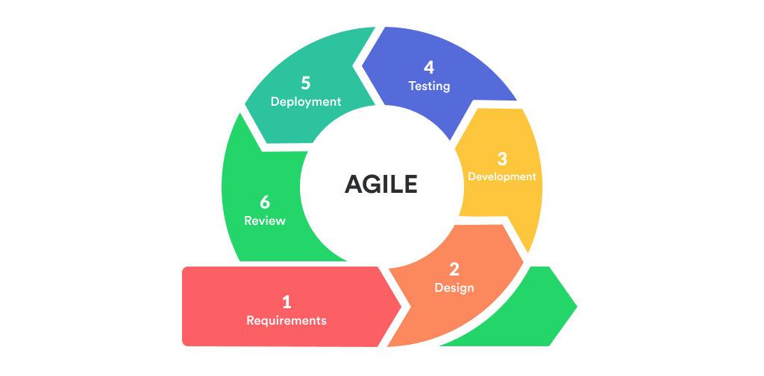
This study adopted Agile methodology, specifically Scrum, to deliver SENTINEL through incremental, testable, and reviewable capability sets.
Figure 5. Agile Model
Development was organized into successive sprints that covered planning, implementation, integration, validation, packaging, review, and refinement. Each sprint used prioritized backlog items tied to operational risk and institutional requirements.
Sprint planning and backlog refinement emphasized high-risk domains, including account governance, workforce continuity, asset compliance, incident coordination, movement monitoring, notification and inbox workflows, guard-safety functions, and decision-support features. Regular integration checkpoints ensured consistency of workflows, system rules, and data behavior.
Validation was embedded throughout the Scrum cycle through scenario-based testing, integration checks, role-permission verification, browser-based acceptance review, and cross-platform runtime review. Sprint reviews documented completed increments, while acceptance checks verified that each increment satisfied defined criteria before carry-forward.
Release readiness was evaluated through structured quality checks, build verification, and governed platform packaging before each major milestone to support controlled rollout decisions and reduce operational disruption. Overall, the methodology shows an Agile approach in which reliability, accountability, security, and usability were developed together with functional scope.

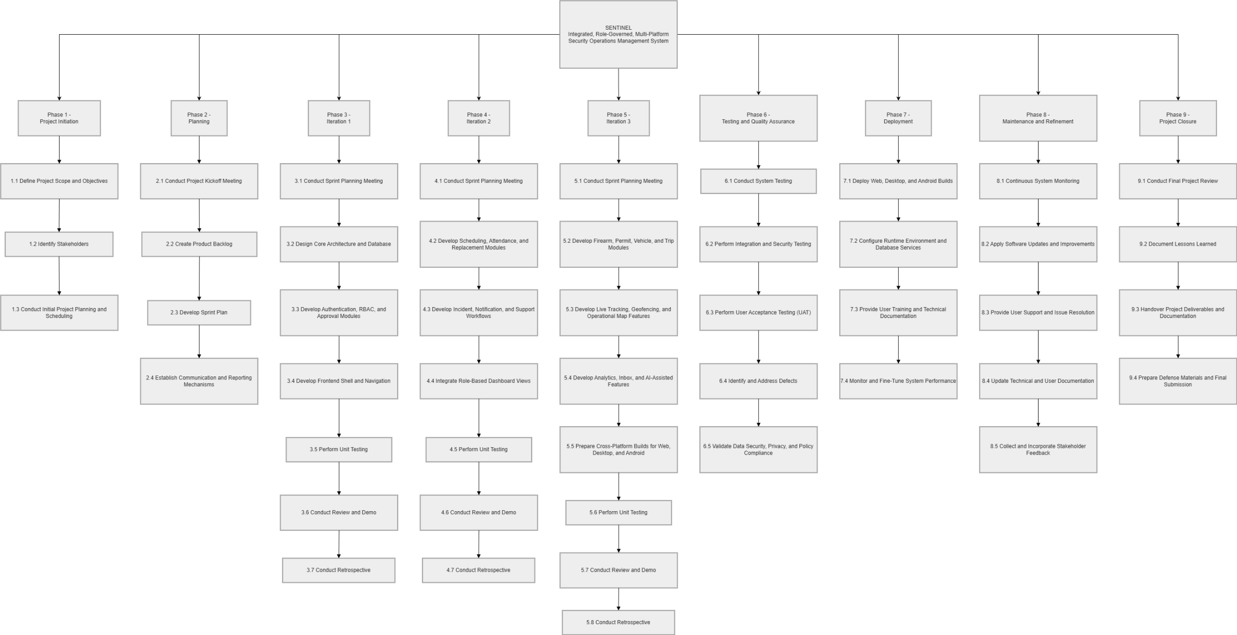
Figure 6. Work Breakdown Structure
Technical Background
Technologies Used in the System
SENTINEL is implemented as a web-first integrated security operations platform with desktop and mobile runtime wrappers. Technology selection was based on concrete implementation requirements: role-based dashboards, secure API contracts, high-concurrency backend operations, traceable relational data, near-real-time tracking, and cross-platform delivery without codebase duplication. The proponents used the following technologies in the current implementation:
Hardware specifications play a crucial role in the development of a web-based platform like SENTINEL, as they directly affect system performance and reliability. To ensure smooth operation during development, deployment, and daily use, the system requires a computer or laptop running on Windows 10 or Windows 11. A processor equivalent to at least a Ryzen 3 is recommended to handle basic processing tasks efficiently. The system should have a minimum of 8 GB of RAM, although 16 GB is preferred for better multitasking and performance. In terms of storage, a 250 GB SSD is required to provide faster data access and improved system responsiveness. Integrated graphics are sufficient for the system’s visual requirements, and a screen resolution of at least 1366x768 is needed for proper interface display. Additionally, a stable broadband internet connection is necessary to support the system’s web-based functionalities.
- React + TypeScript: Used to build reusable, role-aware UI components and dashboard modules with strict typing.
- Vite: Used for local development and production build pipelines.
- Tailwind CSS: Used for responsive interface implementation across command-center, operations, and resource modules.
- Leaflet + OpenStreetMap: Used for operational map rendering, location-marker visualization, and client-site management.
- Rust + Axum: Used for backend API handlers, middleware, and service orchestration.
- PostgreSQL: Used as the central transactional database for users, approvals, schedules, attendance, firearms, vehicles, incidents, notifications, tracking points, and audit logs.
- Docker + Docker Compose: Used to standardize local backend/database orchestration and deployment parity.
- Secure token-based authentication: Used to enforce protected access and session management across user roles.
- Capacitor: Configured as the Android packaging target for the Web frontend, pending signed-device release validation.
- Tauri: Configured as the Windows desktop packaging target for the Web frontend, pending packaged-installer validation.
- Resend: Included in the deployment architecture for transactional email delivery such as verification codes, password reset codes, and operational notifications.
- Railway: Included in the deployment architecture as a cloud deployment target for backend runtime and managed service hosting.
- Namecheap: Included in the deployment architecture for domain registration and domain-level DNS management.
- Git and GitHub: Used for version control, collaboration, change tracking, and release workflow management.
- Android release signing tooling: Configured to support generation and management of the release keystore required for signed APK and AAB distribution, pending release-signing validation.

Gantt Chart of Activities
MONTH | FEBRUARY |  |  |  | MARCH |  |  |  | APRIL |  |  |  | MAY |  |  |  | JUNE |  |  |  | JULY |  |  |  | AUGUST |  |  |  | SEPTEMBER |  |  |  | OCTOBER |  |  |  | NOVEMBER |  |  |  | DECEMBER
ACTIVITY
Project Initiation
Define scope and objectives
Initial planning and scheduling
Planning Kickoff and requirements alignment Sprint planning and reporting setup
Iteration 1: Core architecture and database design Frontend shell, testing, and review
Iteration 2: Scheduling, attendance, and replacement
Review, testing, and retrospective
Iteration 3: Asset, permit, vehicle, and trip modules
Review, testing, and retrospective
Testing and Quality Assurance
System and integration testing
Security, UAT, and defect resolution
Deployment Release preparation and environment setup
User training and technical documentation
Maintenance and Refinement Monitoring and refinements Support and documentation updates
Project Closure Final review and turnover Defense preparation and final submission
Figure 7. Gantt Chart of Activities
Completed | Ongoing |  | Not Started

Legends:

Calendar of Activities
Figure 7 represents the Gantt chart of activities that summarizes the tasks and their duration. Activities are listed on the left, and the schedule is at the top right. Bars indicate task progress, with each bar representing a week. The calendar of activities summarizes the same phased sequence defined in the WBS and Gantt schedule, including objectives, involved personnel, and required resources.
Table 1: Calendar of Activities
Month | Activity | Purpose
February 2026 | Phase 1 - Project Initiation | To define the project scope, identify stakeholders, and prepare the initial development schedule
March 2026 | Phase 2 - Planning | To conduct kickoff activities, organize the product backlog, and establish sprint and reporting mechanisms
April - May 2026 | Phase 3 - Iteration 1 | To build the project foundation through architecture design, database setup, authentication, RBAC, approvals, and frontend shell development
June - July 2026 | Phase 4 - Iteration 2 | To implement workforce continuity workflows, including scheduling, attendance, replacement, incident handling, notifications, and support workflows
August - September 2026 | Phase 5 - Iteration 3 | To implement asset, compliance, tracking, analytics, reporting, and cross-platform packaging features
October 2026 | Phase 6 - Testing and Quality Assurance | To validate end-to-end system behavior, security, role permissions, user acceptance, and defect correction
November 2026 | Phase 7 - Deployment | To prepare release builds, configure runtime environments, and conduct user training and documentation turnover
November - December 2026 | Phase 8 - Maintenance and Refinement | To monitor system performance, address issues, update documentation, and incorporate approved stakeholder feedback
December 2026 | Phase 9 - Project Closure | To complete the final review, consolidate project outputs, prepare defense materials, and hand over deliverables
Table 1 presents the scheduled activities for the development of the SENTINEL system. It outlines the project phases, major activities, and purposes throughout the implementation process.

Requirements Analysis
Table 3. Comparison of the Existing Process and the Proposed Process
Process Area | Existing / Old Process | Proposed Process in SENTINEL | Expected Improvement
Scheduling and workforce continuity | Scheduling, attendance, no-show detection, and replacement coordination depend on manual monitoring and delayed communication. | SENTINEL centralizes schedules, attendance actions, no-show detection, and replacement workflows in a unified operational platform. | Faster response to workforce gaps and improved deployment continuity.
Asset and compliance monitoring | Firearm, permit, vehicle, and trip records are managed through separate or manual records, increasing compliance and traceability risks. | SENTINEL manages firearm, permit, vehicle, trip, and maintenance workflows through centralized and auditable records. | Better compliance visibility, improved accountability, and reduced record fragmentation.
Incident handling and live monitoring | Incident reporting and field monitoring rely on manual updates, weak patrol visibility, and delayed supervisory awareness. | SENTINEL provides structured incident workflows, notifications, live tracking, geofence monitoring, and command dashboards. | Improved situational awareness, faster coordination, and more timely operational intervention.
Auditability and decision support | Operational review depends on scattered records and manual analysis, limiting traceability and data-driven decision-making. | SENTINEL provides audit logs, forensic visibility, operational dashboards, analytics, reports, and rule-based alert outputs. | Stronger traceability, improved review capability, and better-informed command decisions.
Table 3 presents the comparison between the existing process and the proposed process in the SENTINEL system. It highlights the major operational areas in which the traditional manual or fragmented procedures are improved through a more centralized, role-governed, and system-supported approach.
The requirements baseline for SENTINEL was defined from actual private-security operational pain points: fragmented coordination, delayed visibility, compliance exposure, and weak traceability of sensitive asset workflows. Based on current implementation, the requirements analysis prioritizes role-governed access, near-real-time operational awareness, and auditable process execution across personnel, equipment, vehicle, incident, and analytics domains.
Technology and software selection was treated as a requirements decision, not only an implementation preference. For the frontend layer, React + TypeScript + Vite was selected to satisfy modular dashboard composition, strict role-based rendering, and rapid iteration. Angular was considered because it provides a full framework with built-in dependency injection and strong conventions; however, its heavier project structure was less aligned with the team's component-by-component delivery pace. Vue was considered for its simpler learning curve and progressive adoption model, but the existing codebase and shared component strategy were already established around React patterns. Plain JavaScript React was also considered, but TypeScript was chosen to reduce contract errors in role logic, API payload mapping, and cross-module state handling.
For backend processing, Rust + Axum was selected to meet concurrency, security, and reliability requirements for authentication, approvals, tracking, and analytics endpoints. Node.js + Express was considered because of rapid API prototyping and broad ecosystem support, but the project prioritized compile-time safety and stricter runtime guarantees for security-sensitive operations. Java + Spring Boot was considered for enterprise-grade structure and mature tooling, yet it introduces a larger operational footprint and greater configuration overhead for this capstone scope. Go + Gin/Fiber was also considered for performance and simplicity, but Rust + Axum better matched the team's objective of memory-safe, middleware-centric API enforcement with fine-grained control.
For persistence, PostgreSQL was selected because SENTINEL requires relational integrity across users, approvals, shifts, attendance, firearms, vehicles, incidents, and audit records. MySQL/MariaDB were considered because they are widely used relational systems, but PostgreSQL was preferred for stronger advanced SQL features, robust JSONB support, and flexible indexing for mixed transactional and analytical workloads. MongoDB was considered because of schema flexibility and rapid document modeling; however, SENTINEL's compliance and cross-entity constraints require strong relational guarantees that are more naturally enforced in PostgreSQL.
For mapping and geospatial visualization, OpenStreetMap + Leaflet was selected to satisfy near-real-time operational map requirements, client-site management, and location marker rendering while retaining implementation control. Google Maps Platform was considered because it provides high-quality basemaps, geocoding, and route services, but usage-based billing and API quota sensitivity are less favorable for continuous monitoring views. Mapbox was considered because it offers strong vector map tooling and customizable styles, yet recurring usage costs and token-governed access create additional operational dependency for long-running dashboards. ArcGIS was considered for enterprise GIS depth, but its platform complexity exceeds current implementation needs. OpenStreetMap + Leaflet was therefore chosen for cost efficiency, integration flexibility, and direct alignment with the implemented web map architecture.
For near-real-time operational visibility, websocket streaming with polling fallback was selected as a hybrid requirement. Server-Sent Events (SSE) was considered because it simplifies one-way streaming, but websocket transport better supports bidirectional session handling and live snapshot exchange patterns used in tracking views. Polling-only models were considered for implementation simplicity, but they introduce higher latency and unnecessary repeated requests for active command-center monitoring. The implemented websocket-plus-polling model balances responsiveness with continuity when persistent connections are interrupted.
For deployment targets, the system uses a web-first core with Tauri (desktop) and Capacitor (Android) wrappers to meet cross-platform access requirements without maintaining separate business logic per platform. Electron was considered for desktop packaging because of mature tooling, but Tauri was preferred for a lighter runtime footprint and tighter security posture. React Native and fully native Android/desktop tracks were considered for platform-specific delivery, but they would require duplicate UI and integration maintenance. The chosen wrapper strategy reuses the Web application codebase across the configured Windows desktop and Android packaging targets, reducing implementation divergence. Full platform parity remains subject to packaged-runtime validation.
For operational tooling, Docker/Compose, managed runtime deployment, and version-controlled release workflows were selected to satisfy reproducibility and maintainability requirements. Manual host-based installation was considered but increases environment drift and onboarding inconsistency. Alternative orchestration-heavy stacks (for example, immediate Kubernetes adoption) were considered excessive for current scale and capstone constraints. The selected tooling stack provides repeatable setup, traceable change history, and controlled release validation that directly supports the implemented system lifecycle.
Requirements Documentation
Serves as the blueprint for the system’s development, defining the specific capabilities and quality standards necessary to modernize security operations for DASIA. It is divided into Functional Requirements, which detail the distinct tools and permissions for each user role (from high-level Superadmin oversight to Guard field actions), and Non-Functional Requirements, which establish the technical benchmarks for security, real-time performance, and legal compliance.
- All Users
  - The system shall support administrator-mediated onboarding, verification, approval, secure authentication, password-reset workflows, role-based access control, mandatory legal-policy acceptance, and access through the implemented Web application, with configured Windows desktop and Android deployment targets.
- Superadmin
  - The system shall provide superadmin users with command-level dashboards, shared quick Inbox workflows, analytics, performance reports, and operational alerts, ticketing and notification visibility, a feedback dashboard for aggregate and record-level review, audit-log visibility, and forensic audit review for investigative review.
- Admin
  - The system shall enable administrator users to govern personnel workflows, support scheduling and workforce coordination, manage firearm and armored vehicle lifecycle records, access command dashboards and quick Inbox workflows, handle operational ticketing and notifications, and submit authenticated feedback through the constrained feedback workflow.
- Supervisor
  - The system shall enable supervisor users to monitor schedules, attendance, no-show conditions, and replacement actions; access near-real-time tracking, movement history, active deployment, and geofence-alert views; manage authorized operational resources including guard accounts, firearms, vehicles, and client sites; create guard accounts subject to administrator approval; access command dashboards, quick Inbox workflows, reports, alerts, and operational summaries; manage ticketing and notification workflows; and submit authenticated feedback. Supervisors shall not create Supervisor, Admin, or Superadmin accounts, delete user accounts, or modify the system's role-permission policy.
- Guard
  - The system shall enable guard users to access personal schedules and assigned resources, perform attendance-related actions, receive and respond to notifications, submit incident and support-related workflows, use self-scoped live tracking and movement-history features subject to policy and consent controls, access mission-critical field actions such as panic escalation, and submit authenticated feedback.
Non-functional Requirements
The non-functional requirements of SENTINEL emphasize security, performance, usability, reliability, scalability, and compliance traceability. In terms of security, the system shall enforce strong authentication, role-based authorization, approval-gated access, auditable security events, account-protection controls, and abuse-resistance measures to preserve the integrity of operational data and workflows. In terms of performance, the system shall maintain responsive dashboards and timely operational updates suitable for near-real-time supervisory decision-making. With respect to usability, the system shall provide role-centered dashboards and modular user-interface navigation that reduce operator context switching, while further minimizing workflow friction through the use of a shared quick Inbox action for urgent operational work and timeline context. In terms of reliability, the system shall maintain secure session continuity, renewal, and termination behaviors to protect ongoing operations. With respect to scalability, the system architecture shall remain API-driven and modular so that additional modules, integrations, and platform targets may be introduced without requiring a full redesign. Finally, for compliance traceability, legal acceptance and policy-governance events shall be recorded with timestamped metadata suitable for institutional review, accountability, and regulatory compliance.

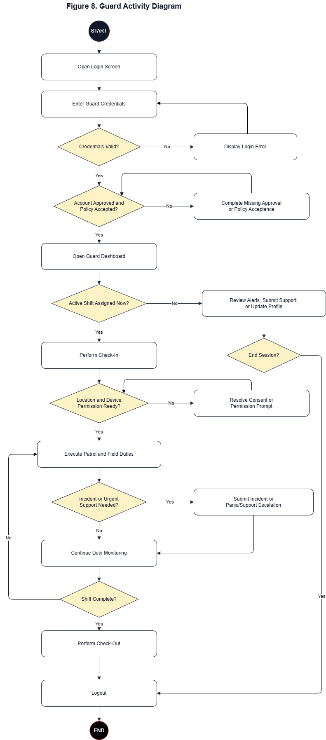
Design of Software, System, Product, and/or Processes
Figure 8. Guard Activity Diagram
Figure 8 illustrates the Guard workflow from authentication to duty completion and secure logout. The flow first validates credentials, then verifies whether account approval and policy acceptance are already in a valid state; if a requirement is missing, the guard completes the required approval or acceptance step before dashboard access proceeds. From the mission-first guard dashboard, the process branches based on whether an active shift is available. If no active shift is assigned, the guard remains on non-duty activities such as reviewing alerts, sending support concerns, and updating profile details. If an active shift exists, the guard performs check-in, confirms location/device access for tracking, executes patrol or assigned field duty, and stays in a duty-monitoring loop. When an incident or urgent support event occurs, the guard submits an incident or panic/support escalation record, then returns to monitoring until check-out and session closure.

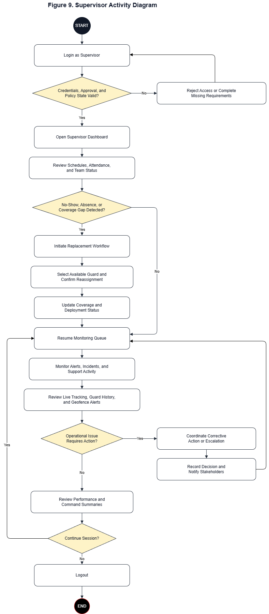
Figure 9. Supervisor Activity Diagram
Figure 9 presents the Supervisor workflow from authenticated access to end-of-session review. After login and access-state validation, the supervisor opens the dashboard to inspect schedules, attendance, and team status. The main control point is staffing-gap detection: when no-show, absence, or coverage gaps are detected, the supervisor initiates replacement coordination by selecting available personnel, issuing reassignment, and confirming deployment before updating operational status. When no immediate gap exists, the supervisor continues command monitoring activities, including incidents, alerts, and support workload. The workflow then moves to live tracking and team-performance review, with an escalation branch for operational issues that requires corrective action logging before returning to monitoring, followed by secure logout.

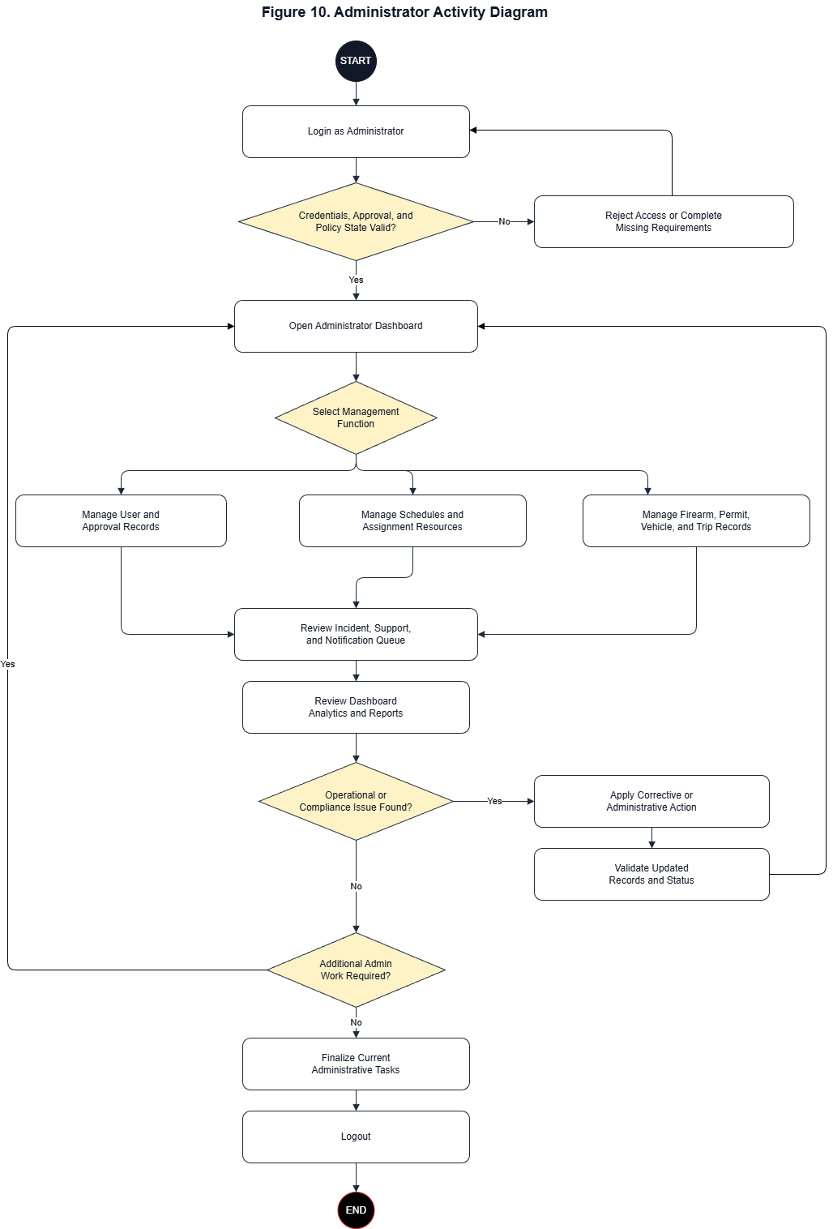
Figure 10. Administrator Activity Diagram
Figure 10 outlines the Administrator workflow as a governed control cycle rather than a single fixed sequence. After successful authentication and access-state checks, the administrator enters the command dashboard and selects the required management function: user/approval records, scheduling and assignment records, or asset/compliance records (firearm, permit, vehicle, and trip). After each management action, updates are reflected in the incident-support-notification queue and in dashboard analytics for operational visibility. If an operational or compliance issue is detected, the administrator applies corrective action, validates updated records, and returns to the management cycle. If no issue is detected, the administrator finalizes the current workset and closes the session through secure logout.

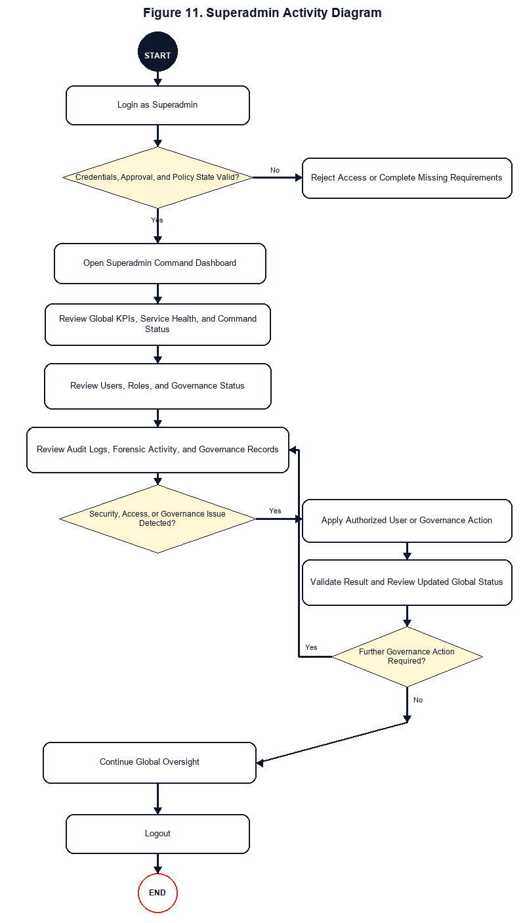
Figure 11. Superadmin Activity Diagram
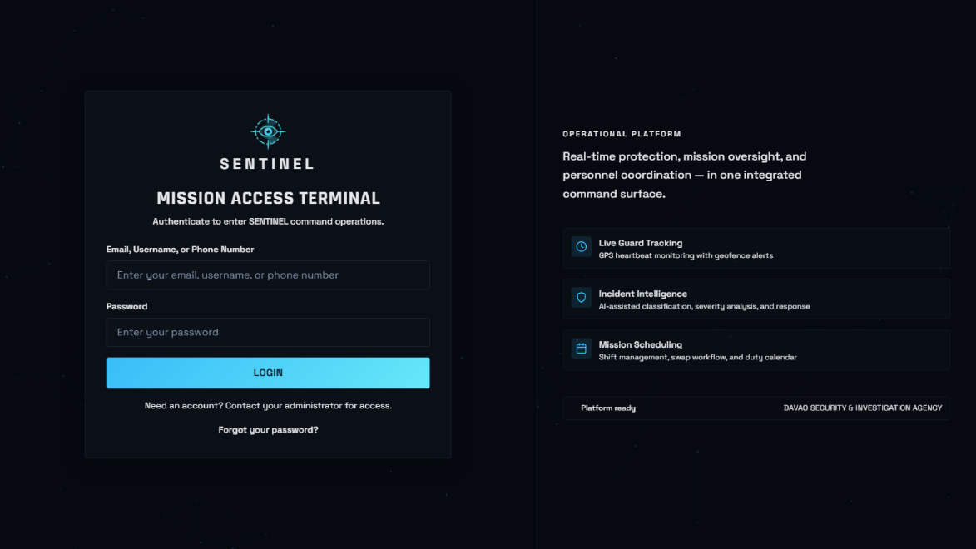
Figure 11 describes the Superadmin workflow as a system-wide governance loop. After login and access-state validation, the superadmin reviews global KPIs, service health, user and role status, audit records, and governance conditions. When an issue is identified, the superadmin performs authorized user-management or governance actions within the system's predefined role-based access rules, validates the result, and continues oversight. The current implementation does not provide runtime editing of the role-permission policy.
Development
SENTINEL was developed through iterative Agile delivery in which user workflows, governance controls, and operational data services progressed in parallel.
This module serves as the secure authentication entry point of the platform. It validates user credentials, enforces role-based access control, and routes users to their authorized operational workspace.
Figure 12. User Login Module

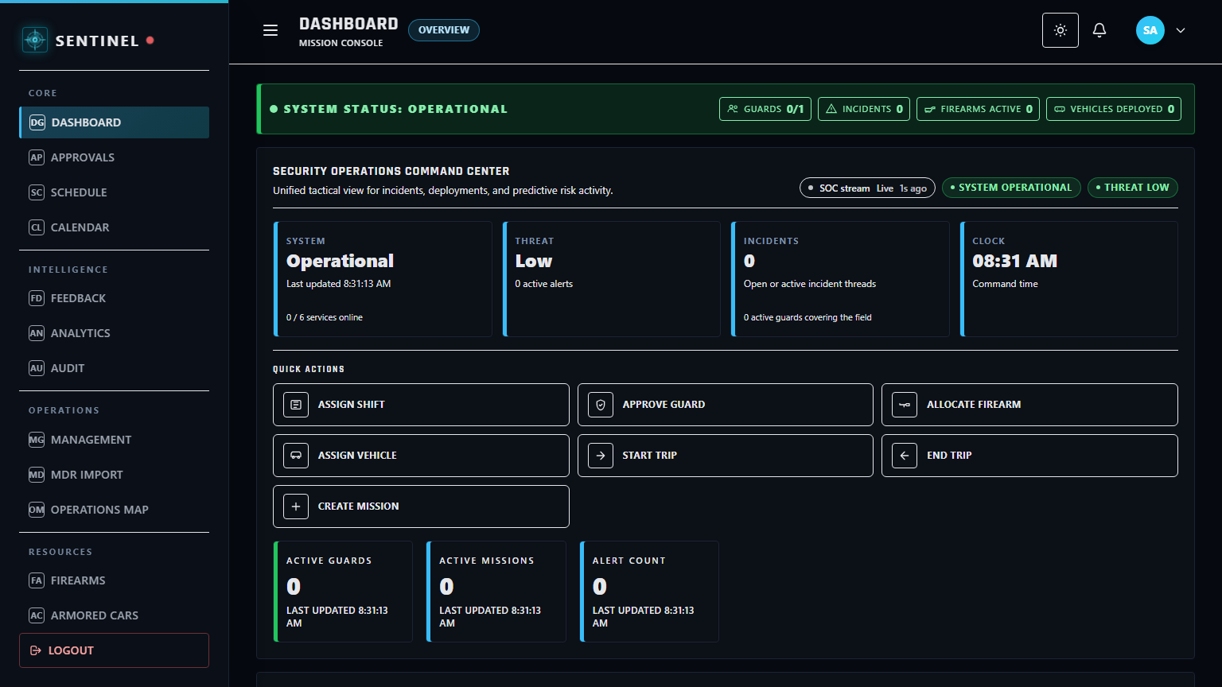
This module serves as the system governance layer for platform-wide control. Superadmin users monitor global KPIs, review command-level operational status, and manage high-level oversight across all modules.
Figure 13. Superadmin Module

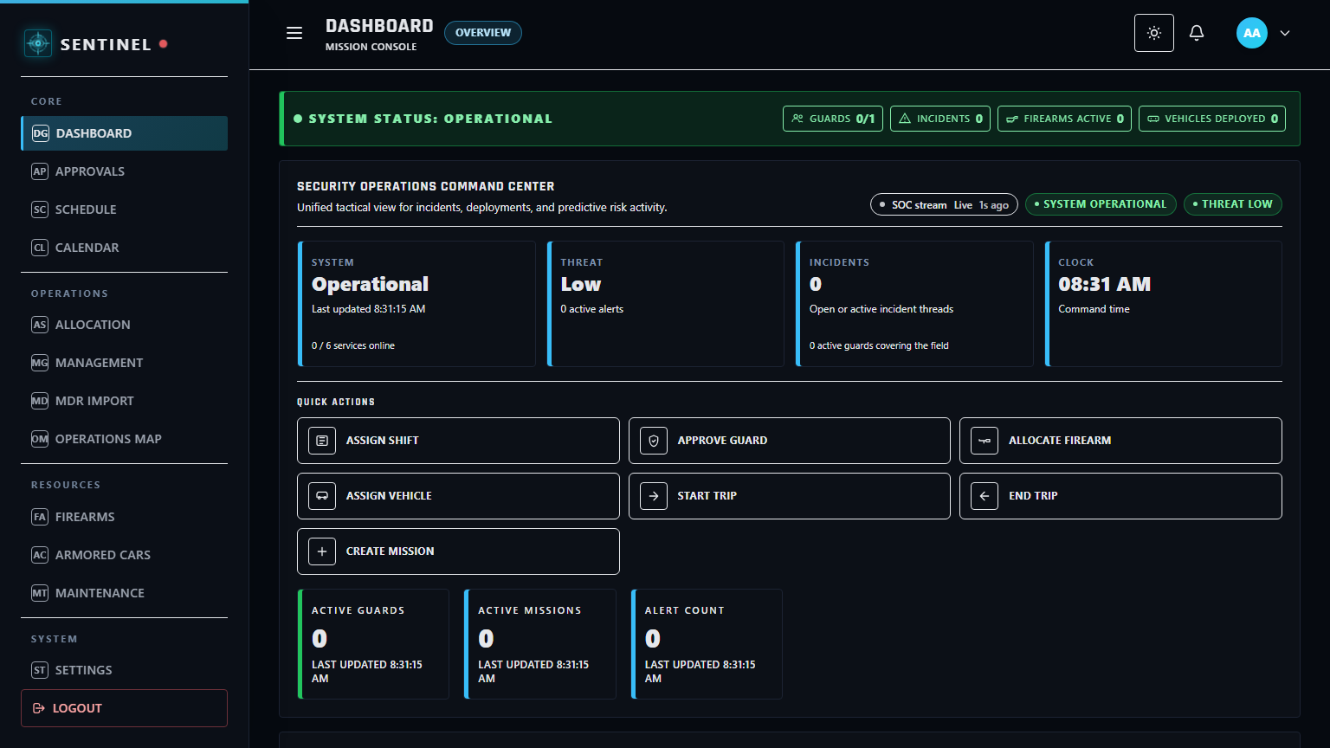
This module serves as the operations management gateway for administrative execution. Administrators manage users, approvals, schedules, and operational records while maintaining day-to-day system continuity.
Figure 14. Administrator Module
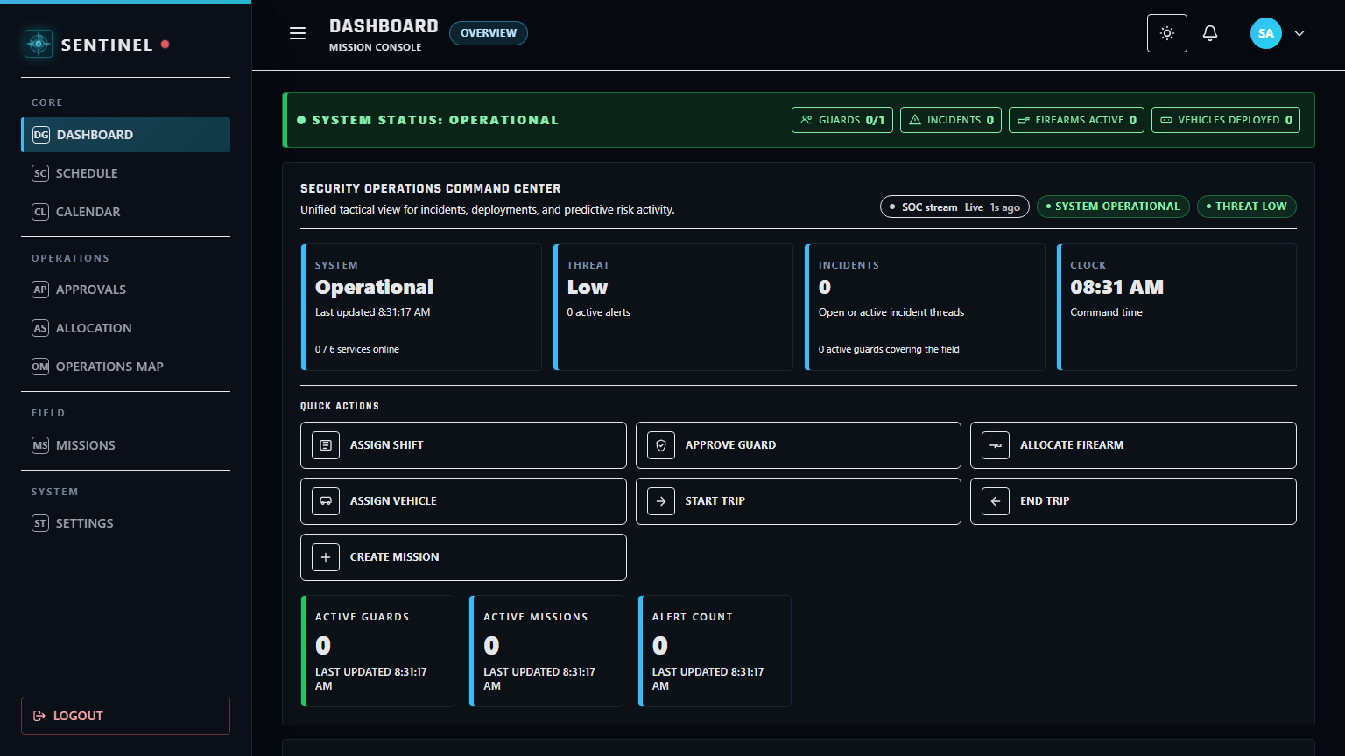
This module serves as the field-supervision workspace for deployment coordination. Supervisors monitor workforce status, schedules, attendance, replacement conditions, and frontline execution while managing authorized operational resources such as guard accounts, firearms, vehicles, and client sites within role-based restrictions.
Figure 15. Supervisor Module

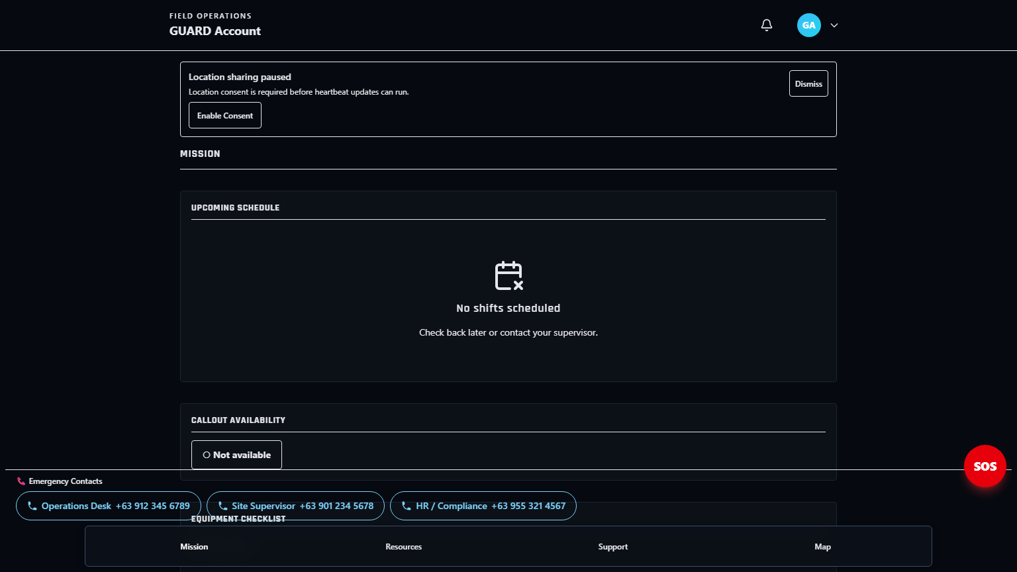
This module serves as the field-user workspace for assigned duty execution. Guards review assignments, update duty actions, submit reports, and use emergency functions for field response support.
Figure 16. Guard Module

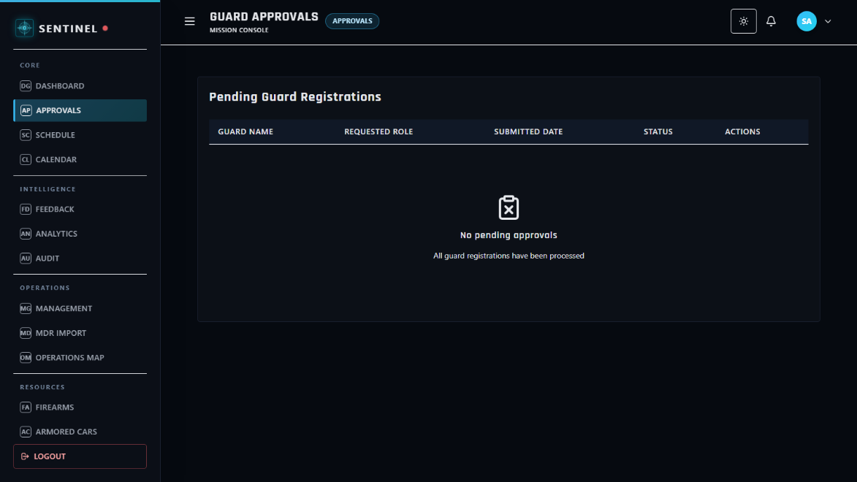
This module serves as the controlled decision layer for requests requiring authorization. Authorized roles review pending items and approve or reject requests to maintain policy compliance.
Figure 17. Approvals Module
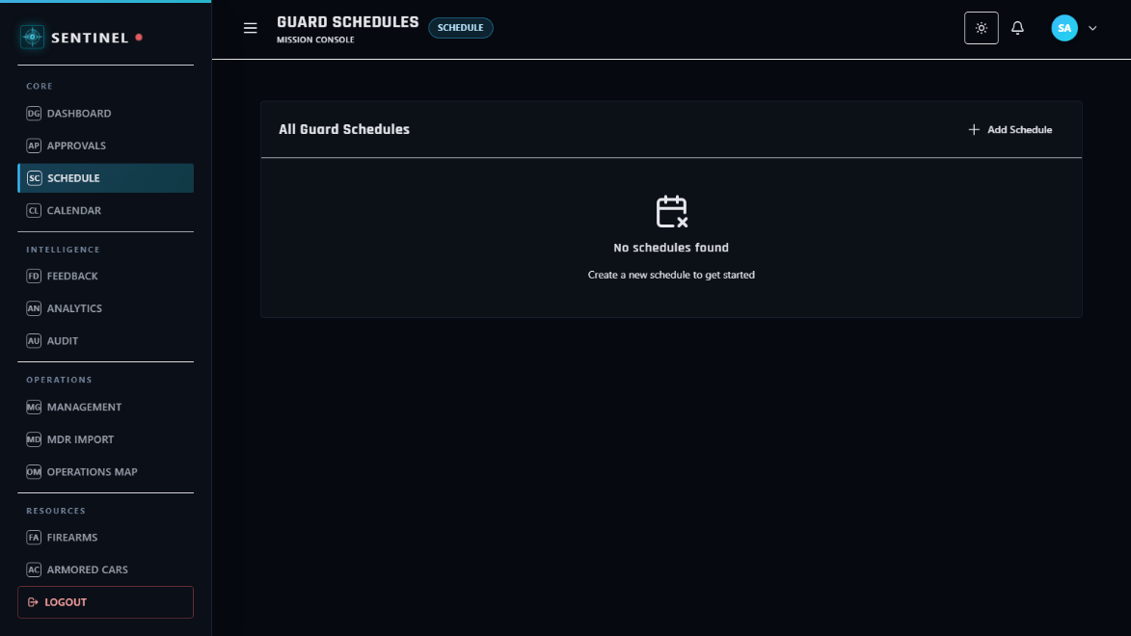
This module serves as the shift-planning and staffing coordination workspace. Authorized command roles create and manage duty schedules, select eligible guards, and assign client sites to support deployment readiness. In the current schedule-creation workflow, guard selection supports searching by human-readable Guard ID or guard name to improve personnel identification.
Figure 18. Scheduling Module

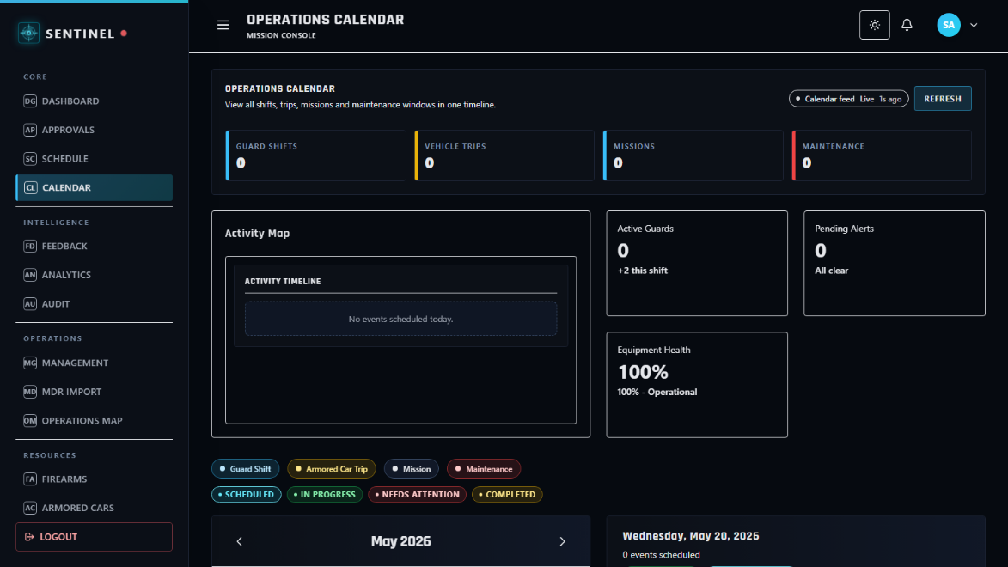
This module serves as the timeline-based view of assignments and duty events. Users review schedule distributions by date to improve planning visibility and conflict awareness.
Figure 19. Calendar Module
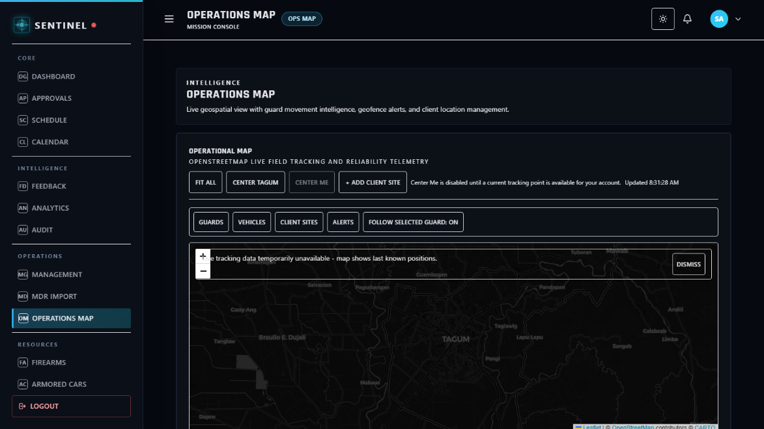
This module serves as the geospatial command surface for operational monitoring. Authorized roles view deployment context and location-based field information to support situational decision-making.
Figure 20. Operations Map Module

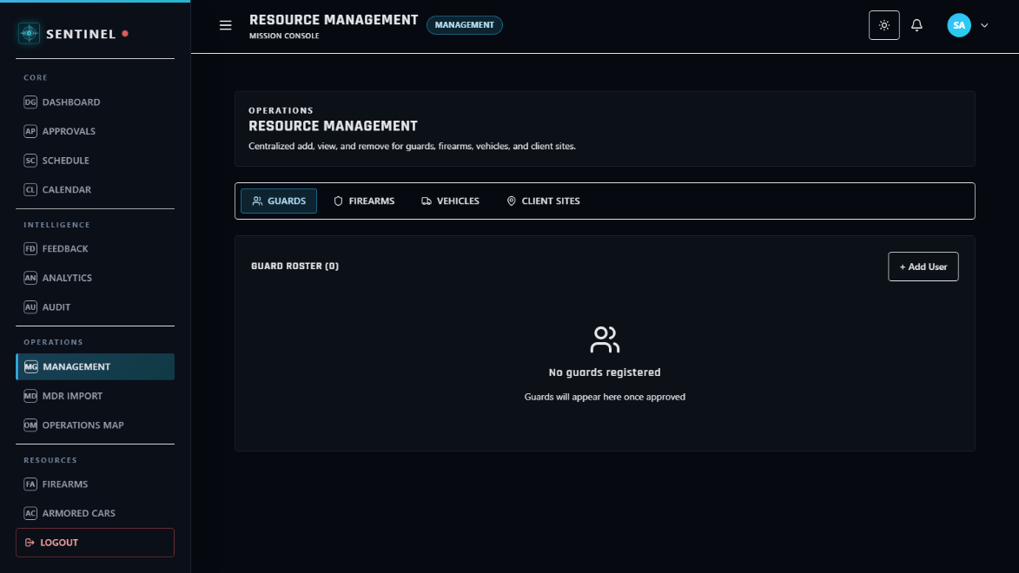
This module serves as the administrative records workspace for organizational control. Authorized roles maintain user-related and operational management data required for system governance.
Figure 21. Management Module
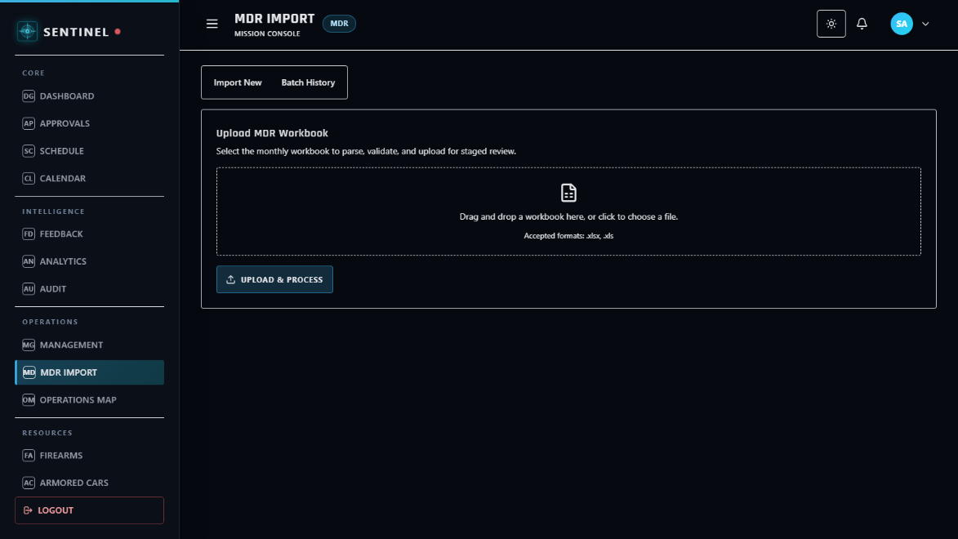
This module serves as the controlled ingestion channel for MDR-based operational records. Administrators import, validate, and process structured workbook data into system-ready entries.
Figure 22. MDR Import Module

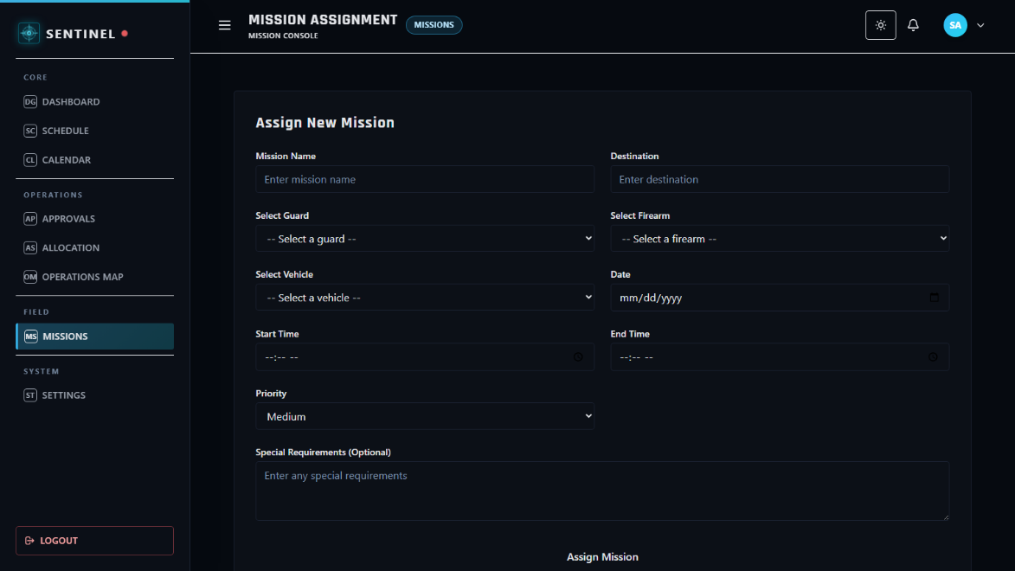
This module serves as the mission coordination workspace for planning and execution tracking. Supervisors and command roles manage mission records to sustain operational flow.
Figure 23. Missions Module
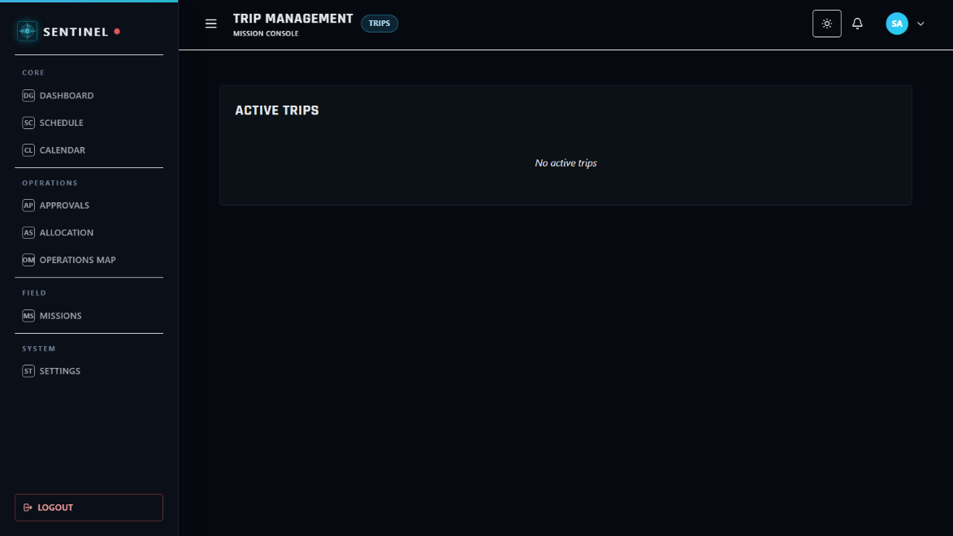
This module serves as the trip lifecycle tracking workspace for field movement operations. Authorized users record and monitor trip activities that support deployment and logistics execution.
Figure 24. Trips Module

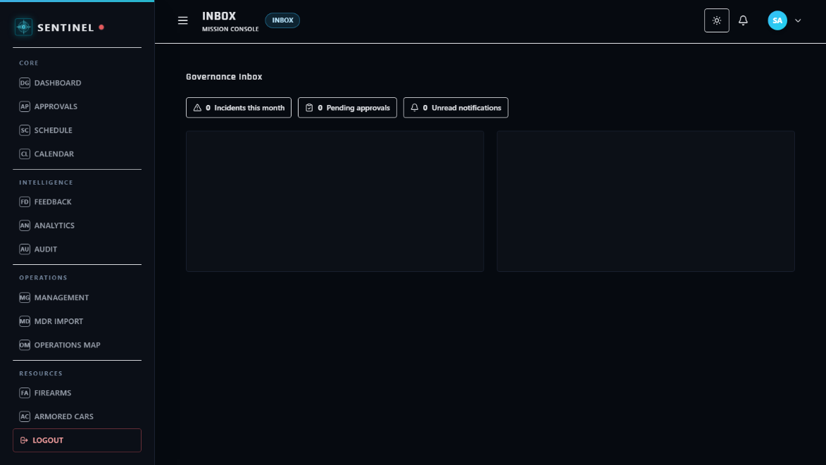
This module serves as the centralized communication panel for operational messages and workflow updates. Users review incoming notifications and pending items that require attention.
Figure 25. Inbox Module
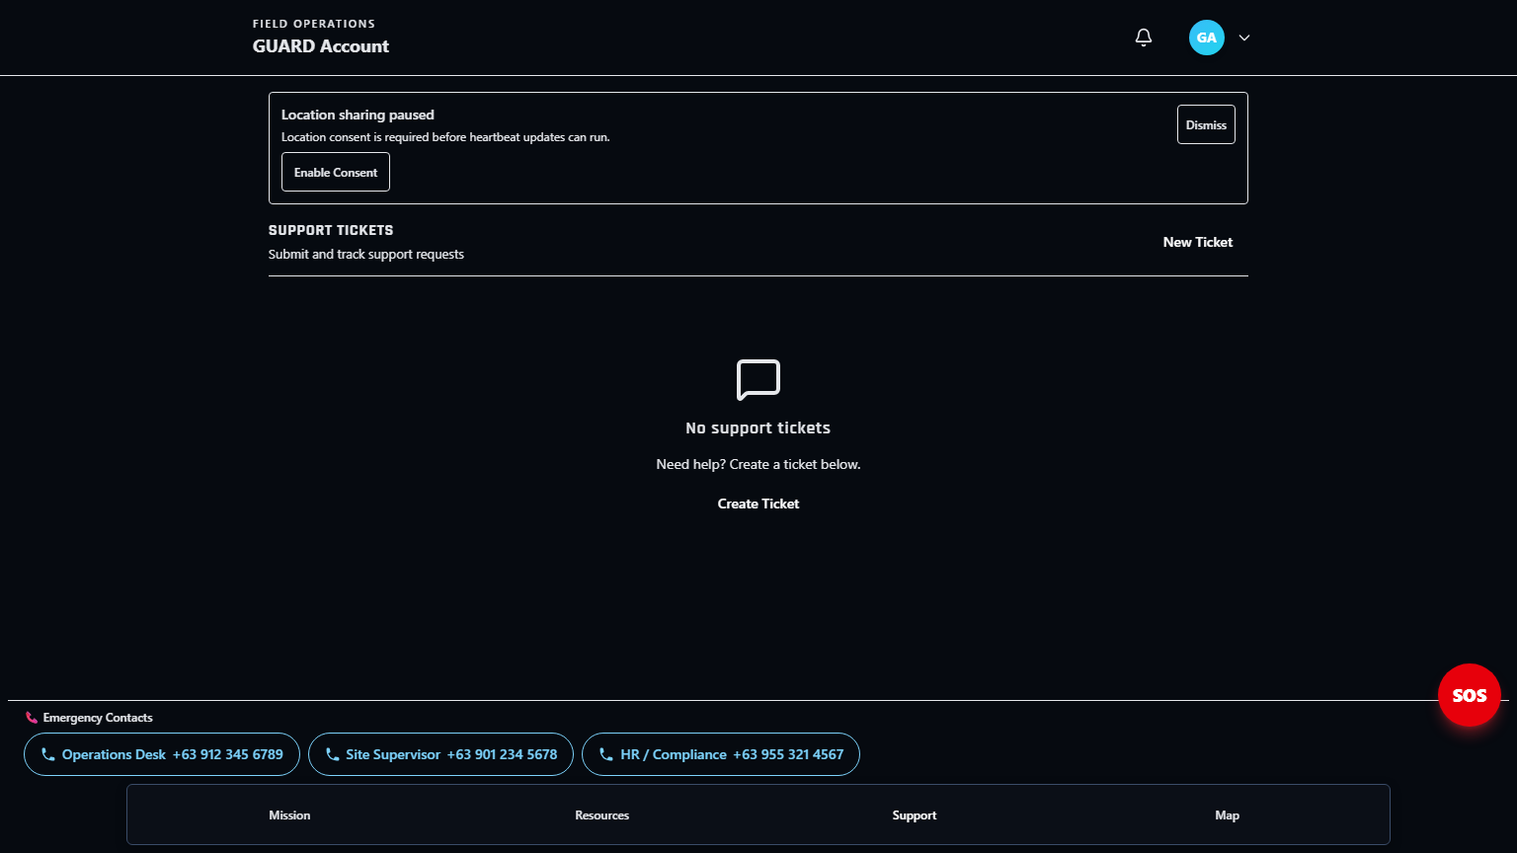
This module serves as the internal assistance channel for operational and technical concerns. Users submit and monitor support requests to resolve system or field-related issues.
Figure 26. Support Module

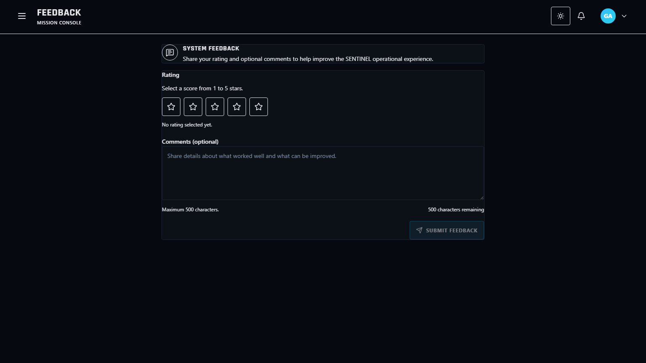
This module serves as the structured user-input channel for usability and operational feedback. Users submit feedback entries that support quality improvement and iterative refinement.
Figure 27. Feedback Submission Module
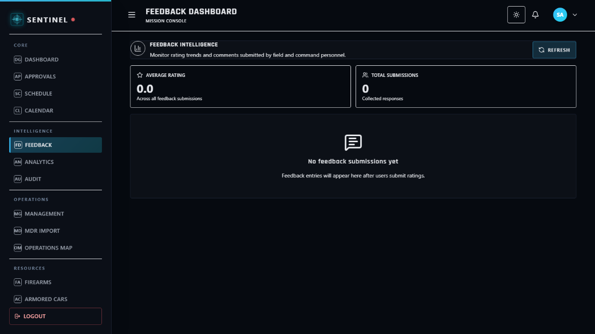
This module serves as the consolidated review panel for submitted feedback. Superadmin users evaluate feedback trends and prioritize action points for system improvement.
Figure 28. Feedback Dashboard Module

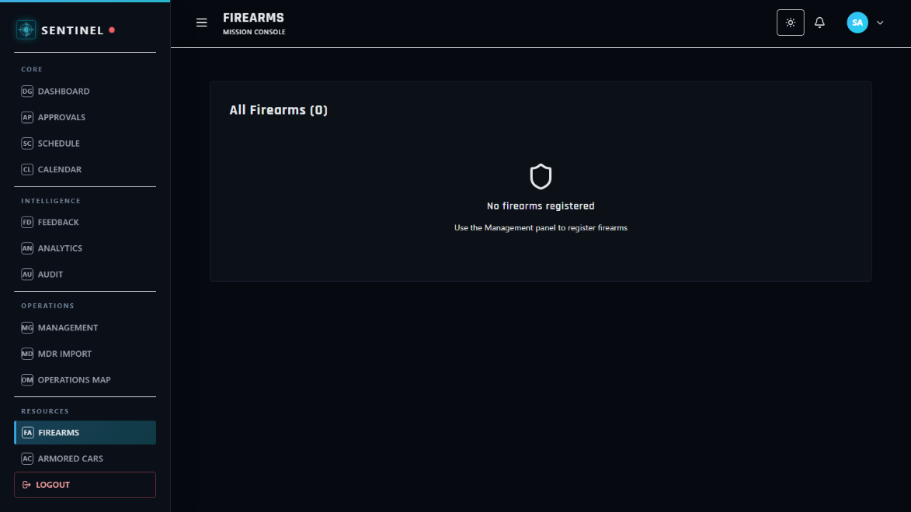
This module serves as the firearm inventory monitoring workspace for controlled assets. Authorized roles track firearm records, status conditions, and operational availability.
Figure 29. Firearms Module
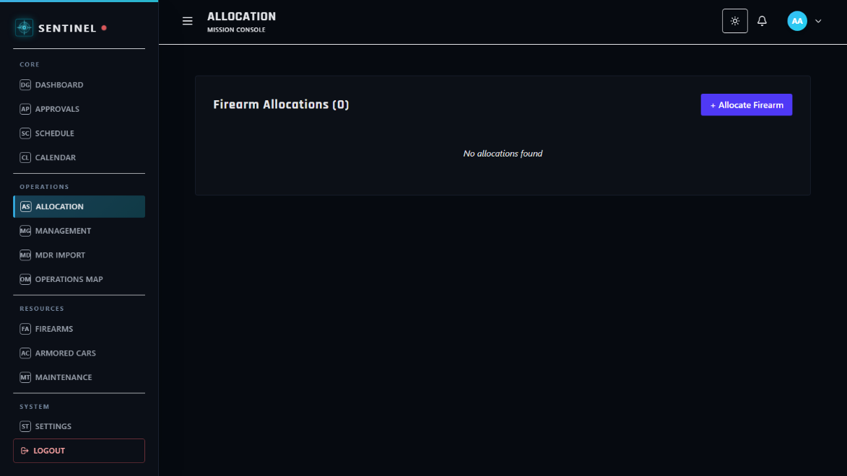
This module serves as the issuance and assignment control workspace for firearms. Authorized roles allocate firearms to personnel while preserving assignment traceability.
Figure 30. Firearms Allocation Module

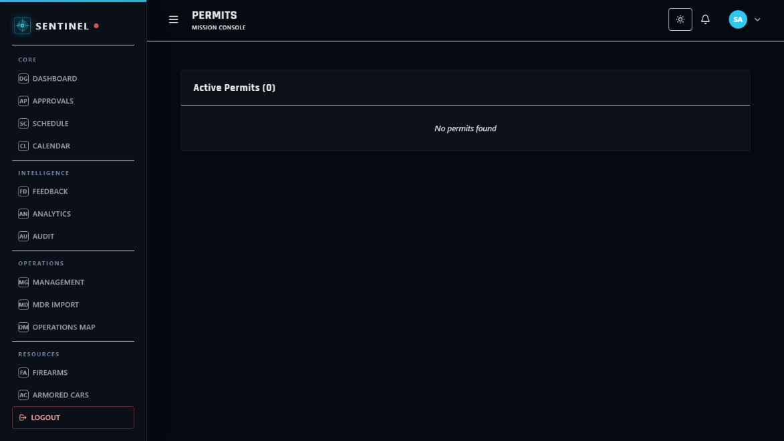
This module serves as the permit compliance workspace for firearm documentation. Authorized roles monitor permit validity and related regulatory records for compliance assurance.
Figure 31. Firearms Permits Module
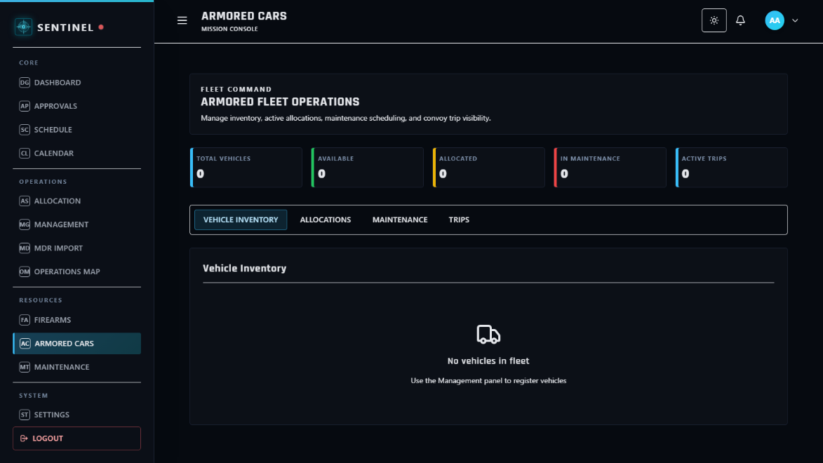
This module serves as the armored vehicle management workspace for transport assets. Authorized users maintain vehicle records and deployment-relevant fleet details.
Figure 32. Armored Cars Module

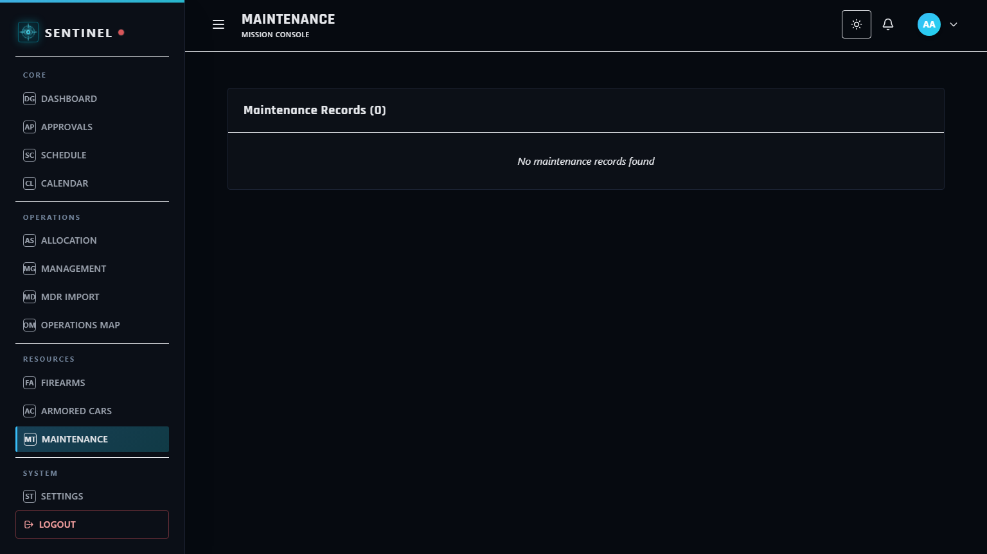
This module serves as the maintenance control workspace for operational assets. Authorized roles track service activities and maintenance schedules to sustain readiness and minimize downtime.
Figure 33. Maintenance Module
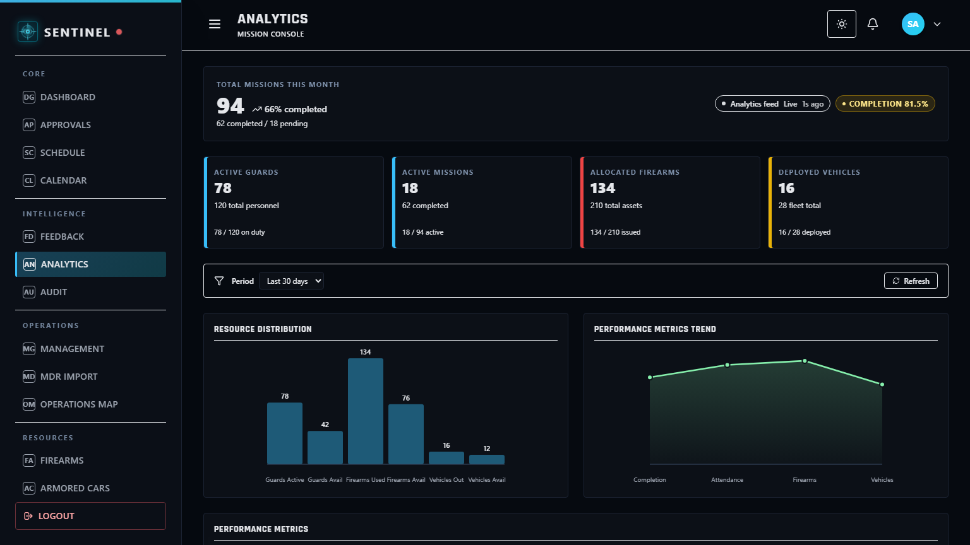
This module serves as the performance analytics workspace for command assessment. Decision-makers review utilization and operational metrics to support rule-based decision support and planning.
Figure 34. Analytics Module

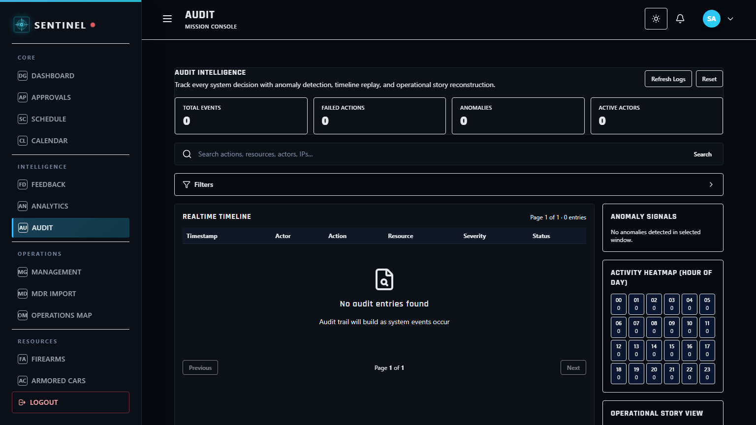
This module serves as the accountability and traceability workspace for system actions. Authorized roles review activity logs and audit records for governance, compliance, and security review.
Figure 35. Audit Module
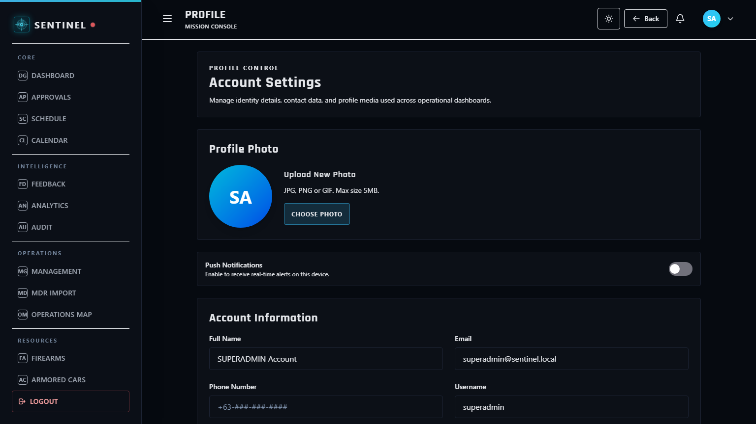
This module serves as the account identity workspace for user-level information management. Users review and update allowed profile details within role-specific access boundaries.
Figure 36. Profile Module

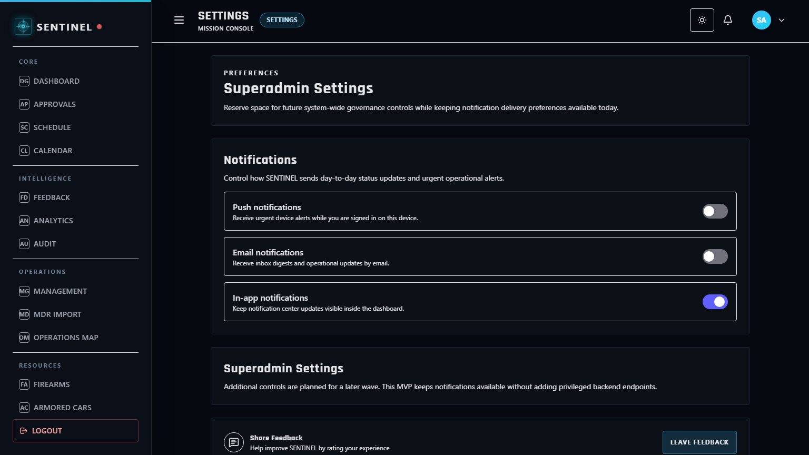
This module serves as the configuration workspace for system and account preferences. Authorized users manage applicable settings that influence workflow behavior and interface operation.
Figure 37. Settings Module

REFERENCES

Abad, R. (2025). How Effective Is Your Security Guard? An Inquiry into the Philippine Private Security Industry. Retrieved from https://doi.org/10.13140/RG.2.2.30981.41442
Aguinis, H. (2022). Performance Management (5th ed.). SAGE Publications. Retrieved from https://edge.sagepub.com/aguinispm5e
Al-Khafajiy, M., et al. (2022). Enabling high performance fog computing through fog-2-fog coordination model. Future Generation Computer Systems. Retrieved from https://doi.org/10.1016/j.future.2022.06.012
Atlam, H. F., & Yang, Y. (2025). Enhancing Healthcare Security: A Unified RBAC and ABAC Risk-Aware Access Control Approach. Retrieved from https://doi.org/10.3390/fi17060262
Department of Information and Communications Technology (DICT). (2024). National Cybersecurity Plan 2023-2028: A Whole-of-Nation Roadmap. Retrieved from https://dict.gov.ph/national-cyber-security-plan
GetApp. (2026). Guardhouse 2026 Pricing, Features, Reviews & Alternatives. Retrieved from https://www.getapp.com/operations-management-software/a/guardhouse/
Guardhouse. (2026). 2026 Pricing, Features, Reviews & Alternatives. Retrieved from https://www.getapp.com/operations-management-software/a/guardhouse/
Hardcat. (2025). Law Enforcement Equipment & Armory Management System: Challenges in Managing Firearms Securely. Retrieved from https://hardcat.com/police-equipment-inventory-tracking/
Jur.ph. (2025). The Private Security Services Industry Act: Law Summary and IRR. Retrieved from https://jur.ph/law/summary/the-private-security-services-industry-act
Khinvasara, T., Shankar, A., & Wong, C. (2024). Survey of Artificial Intelligence for Automated Regulatory Compliance Tracking. Retrieved from https://doi.org/10.9734/jerr/2024/v26i71217
NashTech. (2025). Building High-Performance Web Services with Rust and Axum. Retrieved from https://blog.nashtechglobal.com/building-high-performance-web-services-with-rust-and-axum/
NEDA XI. (2024). Davao Regional Development Plan 2023-2028. National Economic and Development Authority. Retrieved from https://rdc11.neda.gov.ph/rdc-xi-approves-davao-regional-development-plan-2023-2028/
Nguyen, R. (2025). PostgreSQL ACID In-Depth: Reliability and Consistency in Modern Transactions. Retrieved from https://medium.com/engineering/postgresql-acid-in-depth
NODE Magazine. (2026). Why 2026 is the Year Businesses Must Finally Address Admin Overload. Retrieved from https://www.node-magazine.com/thoughtleadership/why-2026-is-the-year-businesses-must-finally-address-admin-overload
Ondos, M. U., & Origines, D. V. (2025). Android-Based Guard Monitoring and Site Surveillance System. Retrieved from https://www.ojs.udb.ac.id/icohetech/article/view/5657
PIA. (2025). Davao City Maintains Top Safety Ranking in Southeast Asia. Philippine Information Agency. Retrieved from https://pia.gov.ph/news/davao-city-maintains-top-safety-ranking-in-southeast-asia/
PostgreSQL Global Development Group. (2025). PostgreSQL 17 Documentation: Data Integrity and ACID Compliance. Retrieved from https://www.postgresql.org/docs/17/acid.html
PNP-SOSIA. (2022). Implementing Rules and Regulations of Republic Act No. 11917. Retrieved from https://www.scribd.com/document/691228276/Approved-IRR-RA-11917
Republic Act No. 11917. (2022). The Private Security Services Industry Act. Retrieved from https://elibrary.judiciary.gov.ph/thebookshelf/showdocs/2/95597
Scofield, M. B. (2025). Rust Axum Web Development: Build High-Performance APIs and Services. Retrieved from https://www.amazon.com/Rust-Axum-Web-Development-High-Performance/dp/B0CX7N4K6J
Securitas. (2026). Control Security from Anywhere - MySecuritas Product Overview. Retrieved from https://www.securitas.com/en/security-solutions/mysecuritas/
Securitas Technology. (2025). 2026 Global Technology Outlook Report: The State of Security Technology. Retrieved from https://www.securitastechnology.com/news/securitas-technology-releases-2026-global-technology-outlook-report
Shiyanbola, J. O., et al. (2023). A Workforce Capacity Optimization Model for Lean Environments. Retrieved from https://www.irejournals.com/paper-details/1704408
Tan, K., et al. (2024). The digital transformation of security and the role of AI. Securitas White Paper. Retrieved from https://www.securitas.ie/news-insights/whitepapers/the-digital-transformation-of-security-and-the-role-of-ai/
TrackTik. (2025). Top 5 End-to-End Security Guard Management Software for 2025. Retrieved from https://www.tracktik.com/resources/blog-articles/top-5-end-to-end-security-guard-management-software-for-2025/
TrackTik. (2025). Physical Security Operations Benchmark Report 2025. Retrieved from https://www.tracktik.com/wp-content/uploads/2025/10/2025BenchmarkReport-1.pdf

